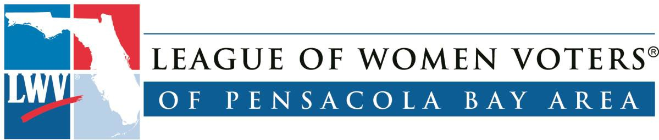

Teacher Manual Escambia County Florida Public Schools
For Local Government Study

This manual was prepared for the use of the Escambia County Florida Public Schools by The League of Women Voters of the Pensacola Bay Area, Education Committee 2013. The contents can also be found at www.lwvpba.org under the heading of “publications.”

Table of Contents

Title Page 1
Table of Contents 2
The Branches of Government 3
Follow Your Florida Legislature 4
Escambia County Districts Map 5
Escambia County Government 6
Escambia County Elected Officials 7 - 10
Escambia County Suggested Projects 11
Pensacola City Council Districts Map 12
Pensacola City Government 13
Pensacola Suggested Projects 14
Town of Century Map 15
Town of Century Government 16

Executive Legislative Judicial
3
Mayor
Elected
County Administrator

Appointed by Board of County Commissioners
The Branches of Government
City Council (5)
One elected per district

City Administrator
Appointed by the City Council
Board of County Commissioners (5) One elected per district
House of Representatives
(120) One elected official per house district

Senate (40) One elected per senatorial district
Governor
Elected

Lieutenant Governor
Elected
ESCAMBIA
COUNTY
TOWN OF
CENTURY
CITY OF
PENSACOLA
STATE OF FLORIDA
FEDERAL
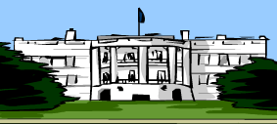
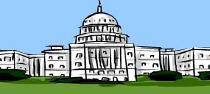
President of the United States Elected

Vice President
Elected

Cabinet
Appointed by the President
House of Representatives (435)
Number of representatives per state based on state population

Senate (100)
Two elected per state
Supreme Court
Nine judges appointed by the President and retained for life

Supreme Court
Nine judges appointed by the governor for a six year term and retained if approved in a general election
Office of County Attorney Appointed by the County Commissioners
City Attorney
Appointed by the Mayor with consent of City Council
Mayor
Elected
Town Council (5)
Elected; every council member represents the entire town
Office of County Attorney Appointed by County Commissioners

Follow Your Florida Legislature

An important part of the business of the two houses of the Florida Legislature is to create the laws needed for the safety and benefit of the people of the state. These laws are proposed as bills by the legislators, reviewed and revised in appropriate committees, and then voted on by the House of Representatives and the Senate separately. When approved by both, they are then sent to the governor for final review and, if approved, signature.

The citizens of the state can follow the proposed pieces of legislature, the bills, on the Internet. If there is a particular subject that a citizen is interested in, the Senate and the House web sites provide search functions where the bills on that subject can be located and followed. In fact, if you have a particular interest in a bill or a group of bills, there is a place to enter your email address and flag those bills. Every time one of your bills moves, you will be notified by email.

A member or a group of members of that body can start a bill in either the House or the Senate. If you have requested to be notified, as either house proposes a bill, you will receive an email telling you its status. When it goes to a committee you will be notified. When it leaves that committee you will learn what the vote was from that committee. It may then go to another committee or to the main body for vote. You will be notified of all this as well.

If the bill starts and passes in the House, then it will go to the Senate. If it starts and passes in the Senate, it then goes to the House. Once it has passed both houses it is sent to the Governor. As you search for a bill on a particular subject, you will usually find that similar bills are being considered in both houses at the same time. These are called companion bills. If a similar bill is traveling through the process in both houses at once, the time it takes to reach the Governor’s desk is considerably shortened. When it finally goes through both houses and is signed by the Governor, it becomes a law.

Suggested activities:
- Go to the Senate’s web site or the House of Representatives’ web site and locate a bill on a subject of interest to you, such as bicycle helmets, or invasive species.
- Find out the status of that bill. Flag that bill to be notified when it moves.
- Look up the committees it goes through. Why was that bill sent to those committees?
- Is that bill partisan? In other words is it of interest to a particular political party? In what way is it partisan, or not?
Resources:
www.flsenate.gov www.myfloridahouse.gov

Escambia County Districts
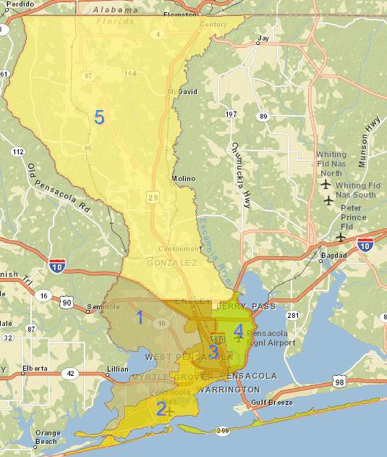

Escambia County Government
The structure of the county government is different from the federal, city and state government in that the county is governed by a group of elected officials called the Board of County Commissioners. Escambia County is divided into 5 districts based on population.
One commissioner for each district is elected by the citizens of each district in a partisan election, for a term of four years. Under the Florida Constitution there are also five elected county officers: Sheriff, Tax Collector, Property Appraiser, Supervisor of Elections, and Clerk of the Circuit Court.

The Board appoints a County Administrator, to be the chief administrative officer of the county, responsible to the Board for the operations of matters within the county’s jurisdiction. The County Administrator has all the executive responsibilities and powers needed to implement the decisions policies, programs and motions made by the Board. He or she also recommends an annual budget both for operations and for capital improvements, which is administered under the supervision of an appointed budget director. Currently there are an assistant county administrator, eleven departments and the Public Information Office under the supervision of the county Administrator.

The Escambia County Board of Commissioners has many boards and committees under its supervision. The Board makes citizens appointments to these various committees based on State Statute or County Ordinance. These include: Animal Services Advisory Committee, Area Housing Commission, BID Inspections Fund Advisory Board (IFAB), Big Bend Health Council. Board of Adjustment, Board of Electrical Examiners, Contractor Competency Board, Enterprise Zone Development Agency Board, Escambia County Mass Transit Advisory Committee, Escambia Marine Advisory Committee, Escambia-Pensacola Human Relations Commission, Extension Council, Fire Prevention Code Board of Appeals, Government Facilities Leasing Corp. Board of Directors, Health Facilities Authority, Housing Finance Authority, Human Services Appropriations, Investment Advisory Committee, Merit System Protection board (MSPB), Pensacola-Escambia Development Commission, Planning Board, Santa Rosa Island Authority, Tourist Development Council, West-End Advisory Committee, West Florida Public Library Board of Trustees, Workforce Escarosa, Inc.

The budget is approved by the Board of County Commissioners and runs for a year beginning October first each year and running through September thirtieth of the following year. The current budget can be found on the county web site at: www.myescambia.com. It is many pages long so it is best to look at it on line. The money to run the county comes from several sources including but not limited to taxes, fees and charges for services.

Escambia County Web site www.myescambia.com.

Escambia County Elected Officials

According to the Florida Constitution, each county of Florida must have the following elected officers: the Board of County Commissioners, Clerk of the Circuit Court, Property Appraiser, Sheriff, and Supervisor of Elections. In addition, Escambia County also elects a School Superintendent, five School Board members, and five Board members for the Emerald Coast Utilities Authority.

While elected officials operate separately, they necessarily cooperate with each other. For example, the Sheriff recommends a budget for his department to the County Commissioners. The Clerk of the Circuit Court maintains
records, such as speeding tickets, obtained from the Sheriff’s Department. These entities interact for the smooth operation of the county.

Board of County Commissioners

The Board is the governing and legislative body of Escambia County, responsible for promoting the health, safety, and quality of life for Escambia County citizens. It approves the county budget, creates ordinances, and collects and levies taxes. In addition, the Board is responsible for developing infrastructure and public services, such as maintaining roads, creating sidewalks, and providing fire protection.

Escambia County has a County Commissioner elected by the voters from each of its five districts. The Board appoints a County Administrator, who is responsible for executing the policies and procedures set forth by the Board. For a more detailed description of the duties and responsibilities of the Board of County Commissioners, refer to the Florida Statutes, Chapter 125.01.

http://www.myescambia.com

Clerk of the Court and Comptroller
The Clerk of the Circuit Court serves myriad roles in order to preserve the trust between the public and government. To do this, the Clerk plays a vital role in the court system by administering court procedures, such as jury duty, and preserving legal documents and records. In Escambia County, the Clerk also serves as an accountant, thereby maintaining the county’s financial integrity. As comptroller, the Clerk ensures county funds are used as directed by the County Commissioners.
http://www.escambiaclerk.com.

Property Appraiser
The Property Appraiser is responsible for determining the value of property for property tax, or ad valorem tax, purposes. To do this, the Property Appraiser maintains all documents and records related to the appraisal of property, including mapped parcels of land, ownership and subdivision maps, and the sales and tax history of a particular piece of property. In addition, the Property Appraiser administers all tax exemptions and determines the eligibility of religious, charitable, and educational property for exemption purposes, as well as widow, widower, and disability exemptions.
http://www.escpa.org

Tax Collector
The Tax Collector is responsible for collecting all taxes and fees owed by citizens. Once the taxes are collected, they will be distributed to public service departments and agencies such as the School Board, Board of County Commissioners, and the Sheriff’s Department. The Tax Collector is also
provides motorist services, such as vehicle registration, drivers’ licenses, and proof of insurance, and he issues hunting and fishing licenses.
http://www.escambiataxcollector.com/

Sheriff
The Sheriff is the highest-ranking law enforcement officer in the county, responsible for enforcing laws in order to keep citizens safe. The sheriff may also recommend policy to the board of county commissioners to make the county safer.

In Escambia County, the Sheriff’s Department has various programs in place to protect the local community. It is charged with keeping the public safe from potential crime activity through technology, responding to crime activity, and educating citizens about preventive measures to keep their own neighborhoods and community safe.
http://www.escambiaso.com/

Supervisor of Elections
The Supervisor of Elections administers all federal, state, county, municipal, and special district elections in Escambia County. Accordingly, the Supervisor is responsible providing voter services, maintaining all information related to elections and election results, providing information to prospective candidates, and educating voters about elections or other election related news. For example, the supervisor of elections provides voter registration, composes and prints ballots, approves and selects polling places, and recruits and trains poll workers.
http://www.escambiavotes.com

Escambia County School District Superintendent
The Superintendent is responsible for overseeing the successful management of the school district. Along with the School Board he creates a vision, or a mission, for the school district to ultimately ensure that all students receive a quality education. In general, this includes outlining a budget for all school- related operations, ensuring that faculty and staff are qualified to perform their jobs, and providing leadership on effective curriculum for students.

District Board Members
Working with the Superintendent, the five local School Board members create policy and establish rules for the local school system in accordance with state and federal law. Input from the community is necessary in order to identify and respond to the needs of the community.

There are five School board districts, with one board member elected from each. Each must live in the district in which they are elected. The board holds a public meeting each month and hears ideas from the local community to improve the school system. http://www.escambia.k12.fl.us/Master/index.asp

Emerald Coast Utilities Authority (ECUA)

District Board Members
The five ECUA District Board Members are responsible for the successful management and implementation of sanitation, water, and wastewater services. They create and oversee the trash collection and recycling. They manage the sewer system.

There are five district board members, one member elected per district. They must live in the district in which they are elected. They hold a meeting once a month and hear from the public for ideas to improve the services provided by ECUA.
http://ecua.fl.gov

Escambia County Suggested Projects

What county district do you live in? Locate it on the map. Who is your commissioner?

- Go to the Escambia County web site. Find out when the next meeting of the Board of County Commissioners will be. Find out what will be on the agenda.
- On the county web site, look at one of the recorded meetings of the Board of County Commissioners. What did they discuss? What did they decide?
- Select a topic of interest to you about the county and write a letter to your commissioner asking about it, or expressing your interest.
- What number in Escambia County would you call for a non-emergency request?
- What is the largest source of money for the county? What is the biggest expense?
- Choose two committees that are under the supervision of the Board of county commissioners. Describe what they do.
- If Escambia County Mass Transit Advisory committee decided that there was a need to increase the number of bus routes, what would it have to do, to get this done? Who would decide?
- If you live in the county, what color are your curbside garbage containers? What days are garbage and recyclables collected? Where does the garbage go? What happens to it? Where do recyclables go?
- How many offices does the sheriff have in Escambia County? How many deputies are there?

www.myescambia.com

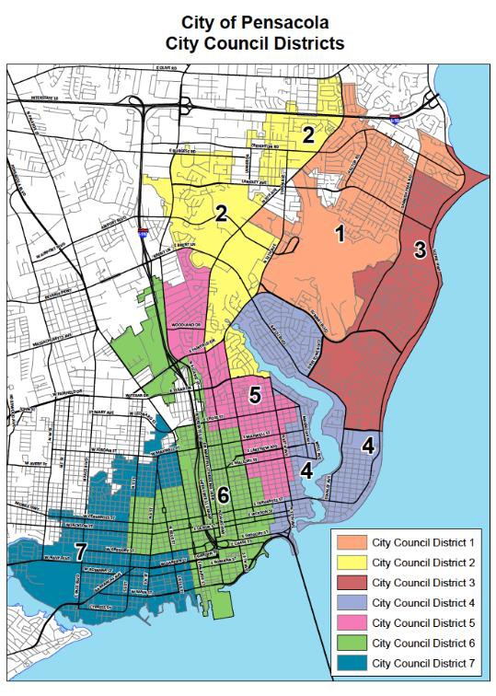

Pensacola City Government

The structure of the government of the city of Pensacola is determined by Charter. The current Charter was adopted by a vote of the citizens in 2009. Pensacola City structure is called a Mayor-Council form of government. It is similar to the government of the United States in that it has an executive branch and a legislative branch. The Charter is reviewed every 10 years and may be revised by a vote of the citizens.

The executive branch is headed by the Mayor, who is elected for a term of four years by the citizens. This is a full time job. It includes supervision of all departments of the city government. The mayor can appoint, discipline, or remove all officers and employees. He presents recommendations to the City Council on the requirements of municipal (city) government. He also is responsible for submitting a budget to the City Council for amendment and approval.

Departments of city government:
City Attorney, Office of Sustainability, City Clerk, Airport, Police, Fire, Code Enforcement, Community Redevelopment, Energy, Financial Resources, Neighborhood Services, Planning Services, Port of Pensacola, Purchasing, Saenger Theater, Sanitation Services and Fleet Management.

The legislative branch is the City Council. The City Council members are elected by the citizens for a four year term. Their job is considered to be part time. The Council legislates by adopting ordinances and resolutions. It also adopts the budget for the city. It has the power to investigate the conduct of any office, department, agency or officer and any city affairs.

The City Council holds regular public meetings at which proposals are voted on. Interested citizens may appear at these public meetings and speak in favor or against the proposals which are to be voted on. The meetings are held in the Council Chambers on the first floor of City Hall. They are televised and may be watched live on public TV or recorded through a link on the Pensacola web site. The City Council also has meetings called workshops. At these meetings, proposals are discussed, debated, and amended. They are then put on the agenda for the next public meeting.
The Sunshine Law: All meetings of the City Council are subject to the “Sunshine Law” which states that when any of the council members meet to discuss business of the Council, all of the members must be present and the meeting must be open to the public.

Finance: The money for running the city government comes from several sources. The largest part of the income (about 25%) is from property (Ad Valorem) taxes. There is income from licenses, permitting fees and fines. There is some small (4.8%) income for cost sharing for specific purposes from Escambia County, the State of Florida, and the Federal Government.

Source: http://www.cityofpensacola.com.

Suggested Projects:

What is your City Council district number? Who is your City Council representative? Watch a City Council meeting on TV, noting the actions of your representative in particular.
- Is there an issue that your representative expressed an opinion or position on? Do you understand his or her reasoning for that opinion? Please explain his or her position. Do you agree or disagree and why? Write a letter to your representative on this topic. Or make an appointment to talk to your representative about this. Report on how this interaction worked out.
- Where does the city get its money? How is this money collected? What does the city spend money on? What happens if there is not enough money to cover the expense? Who decides if taxes or fees need to be raised? Who decides if a service needs to be cut and by how much?
- Explain the “Sunshine Law” as it applies to city government.
- What is the difference between the Community Development Department and the Office of Sustainability? How do they interact? Might what they do, impact the Energy Department?
- Collect information about a local topic that interests you, such as speed limits, speed bumps, garbage collection and disposal, stoplights, stop signs, parks, summer recreation projects, leash laws, or noise ordinances. Is this a city, county, or state area of control? Find out which department oversees that area, how they make decisions, and where their money comes from. Write a letter to the appropriate representative about your interest. Report on the response.
- During an election, research one or two candidates for one office. Find out what qualifications he or she has for that job. Find out what their goals are, if elected. Do you agree with these goals? Are they something that a person in that job could actually do? Where would the money for accomplishing those goals come from?
- How can you find out what ships are in port and what cargo they are loading?
- What department is responsible for the running f the Cecil Hunter pool? What hours is it open? Is there a fee to swim? How far is it from our house?
- What are the qualifications and pay to be an airport electrician? 10)What number would you call for a non-emergency request?

Century, Florida

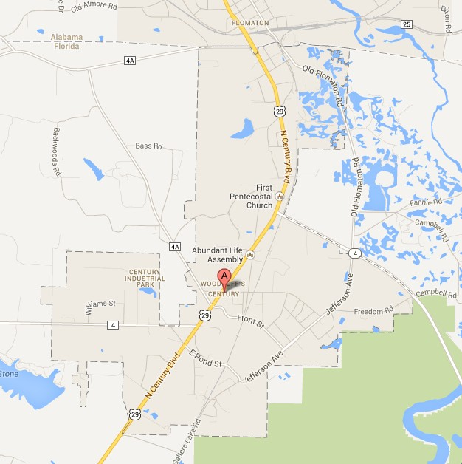

Town of Century Local Government

The structure of the Town of Century local government is called weak mayor – strong council. There is an Executive Branch and a legislative branch.
As the town administrator, the Mayor heads the executive branch of government. The Mayor is elected for a four-year term. Mayor of Century is considered a full time job and carries with it the authority to make policy recommendations to the council. He/she oversees Departments of Water- Sewer, Natural Gas, and Streets of which Parks is a subsidiary. Employees report to the Mayor who has the authority to have conversations with them and write up any discipline issues which he /she then takes to the Council for action.

The Town Council serves as the legislative branch. The Council consists of 5 members elected by the public for four-year terms, also. The position is considered part time. The Mayor is a non-voting member. The President is elected from and by the members of the Council. The Council meets the first and third Mondays of each month. The Clerk’s office prepares and sends out packets of materials for the meeting on the Friday before the meeting.
Policy is set by vote of the council.

As is required by Florida law, all business of the Town of Century is conducted in accordance with the Sunshine Law.

All finances for operating the town come from Property (Ad Valorem) taxes, the sale of water and natural gas, a local business tax, and a ½ cent sales tax from the state. They receive grants from the federal government for rural development but the funds are not used as part of the operating budget. www.centuryflorida.com

