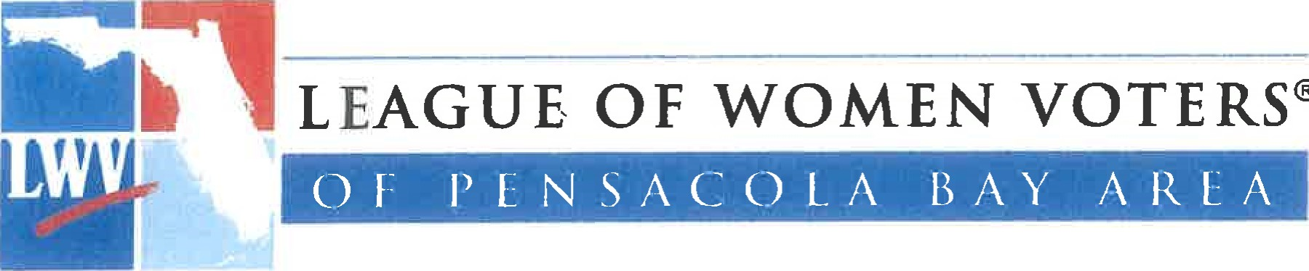
^{O}

Teacher Manual
Santa Rosa County Florida
Public Schools
For Local Government Study
This manual was prepared for the use of the Santa Rosa County Florida Public Schools by the League of Women Voters of the Pensacola Bay Area, Education committee 2014. The contents can also be found at www.lwvpba.org under the heading of "publications."

Table of Contents
Title Page 1
Table of Contents 2
Branches of Government 3
Santa Rosa County Government 4
Santa Rosa County Elected Officials 5-8
Santa Rosa County District Map 9
Santa Rosa County Suggested Activities 10
Milton City Government 11-13
Gulf Breeze City Government 14-18
Jay Town Government 19-22
Follow Your State Legislature 23-24

Executive Legislative Judicial
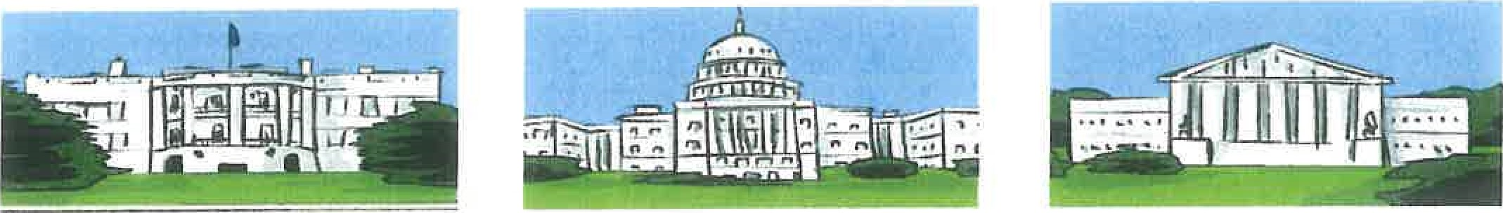

President of the House of Supreme Court
United States Representatives (435)
Elected Number of representatives Nine judges appointed by the varies by state population President approved by the
Cabinet Senate and retained for life
Appointed by the President Senate (100)
 | Two elected per state | Supreme Court
Governor | House of
Elected | Representatives (120) | Nine judges appointed by the
One per house district
Governor and are retained by
Lieutenant Governor a general election after 6
Elected Senate (40)
years of service
One per senatorial district
FLORIDA SUPREME COURT
County Administrator | Board of County
z Commissioners (5)
Appointed by Board of County One commissioner elected Appointed by Governor Commissioners per district
z
Mayor — Elected City Council DISTRICT ONE CIRCUIT COURT
City Manager — Hired by City Two representatives from
Elected by Voters
Council each of four wards
Mayor - Elected Town Council DISTRICT ONE CIRCUIT COURT
Town Clerk - Hired by Town Four Elected Members z
Elected by Voters
Council
N
Mayor - Elected City Council DISTRICT ONE CIRCUIT COURT
City Manager — Hired by City Four Members elected for
Elected by Voters
Council 4-year term

Santa Rosa County Government
The government of Santa Rosa County is different from the government of the federal, city, or state government in that the county is governed by a group of elected officials called the Board of County Commissioners (the Board). Santa Rosa County is governed by 5 commissioners. They are elected for four year terms, by the vote of all the registered voters in the county. Each one represents an individual district as well as the whole county. They hold four meetings a month at which the public is invited to attend and to speak The meetings are also streamed online.
The Board serves as the legislative and policy setting branch of government. There are also five other elected members of the county government under the Florida constitution. They are Sheriff, Tax Collector, Clerk of Circuit Court, Property Appraiser, and Supervisor of Elections.
The Board appoints a County Administrator who is responsible for the day-to-day operations of the county government. It is his job to assure that the policies and procedures set by the Board are carried out thoroughly and efficiently. All department heads and their staffs are under his supervision. There are 24 services under his supervision. These can be found listed on the county web site. He also prepares an annual county budget, policy recommendations, agendas and goals, for consideration by the Board.
The county budget is proposed by the County Administrator and is adjusted, amended and finally approved by the Board. Revenue comes from taxes, licenses and other fees, fines, charges for services, and intergovernmental (from state or federal government). The office of the budget is responsible for seeing that that the county departments have the resources they need and that the funds are spent properly.
The Board appoints a County Attorney. The County Attorney serves as chief legal counsel to the Board on all legal matters. She does legal research and prepares legal documents. She attends mediation and arbitration meetings. She also represents Santa Rosa County in all noncriminal litigation in state and federal court.
Santa Rosa County Web Site: www.santarosa.fl.gov

Santa Rosa County Elected Officials
According to the Florida Constitution each county must elect the following officers: a Board of County Commissioners (the Board), Clerk of Circuit Court, Property Appraiser, Tax Collector, Sheriff and Supervisor of Elections. These are called Constitutional Officers. In addition, Santa Rosa County also elects, a Superintendent of Schools and a five member School Board.
While these elected officials operate separately, they necessarily cooperate with each other. For example, they each have to submit their budget requests to the Board for approval. The Clerk of the Circuit Court maintains records, such as speeding tickets, obtained from the Sheriffs Department. The Property Appraiser lets the Tax Assessor know how much a property is worth so proper taxes can be assessed. Cooperation is essential for the smooth functioning of county government.

Board of County Commissioners
This elected group of county officials is described on the preceding page. For more details, refer to the Florida Statutes, chapter 125.01.
Clerk of the Circuit Court
The office of the Clerk of the Circuit Court is in charge of record keeping and financial management for the county. The clerk serves as auditor and accountant for the county, making sure that county money is handled according to law and county policy. He is the guardian of public records. He maintains court records and administers court procedures such as jury duty. He handles court ordered assessments, such as fines, child support and alimony payments. www.Santarosaclerk.com

Property Appraiser
The primary duty of the Tax Appraiser is to identify, locate and value all property in the county, for purposes of ad valorum or property tax collection. He is the custodian of certain county property records of ownership, maps, sales data, and prior tax rolls. He is a primary source of information which is valuable to the county and to individuals. www.Srcpa.org

Tax Collector
The duties of the Tax Collector include collecting all property and business taxes and some fees owed by citizens. Once collected, the funds are accounted by the budget office and distributed to the various departments according to the county budget. The tax collector also provides some motorist services, such as vehicle and vessel registration, drivers' licenses, and proof of insurance. He also issues licenses for hunting and fishing. www.srctc.com
Sheriff
The sheriff has a duty to enforce the Florida Constitution, and Florida
State laws and to execute the orders of the Board of County Commissioners. He provides security and safety for the county's citizens, by appointing deputies who act in his name and office to enforce appropriate laws, execute writs, and warrants, as requested, and maintain the peace. www.santarosasheriff.org

Supervisor of Elections
The Supervisor of Elections administers all federal, state, county, municipal, and special elections in Santa Rosa County. Accordingly, the Supervisor is responsible for providing voter services, maintaining all information related to elections and election results, providing information to prospective candidates, and educating voters about elections. For example, the Supervisor of Elections provides voter registration, composes and prints ballots, approves and selects polling places, and recruits and trains poll workers. www.votesantarosa.com

Santa Rosa County School District Superintendent
The Superintendent is responsible for overseeing the successful management of the school district. Along with the School board he creates a vision or mission, for the district to ensure that all students receive a quality education as required by the Florida constitution. In general, this includes outlining a budget for all school related operations, ensuring that faculty and staff are qualified to perform their jobs, and providing leadership on effective curriculum for students. www.santarosa.k12.fl.us.

District School Board
Working with the Superintendent, the five School Board members create policy and establish rules for the local school system in accordance with state and federal law. Input from the citizens is necessary in order to identify and respond to the needs of the community.
There are 5 School Board districts with one board member from each. Each board member must live in the district from which he is elected. Board members are elected by the voters of the county for four year terms. The school board holds public meetings once a month and hears ideas and suggestions from the local community to improve the schools.
.santa

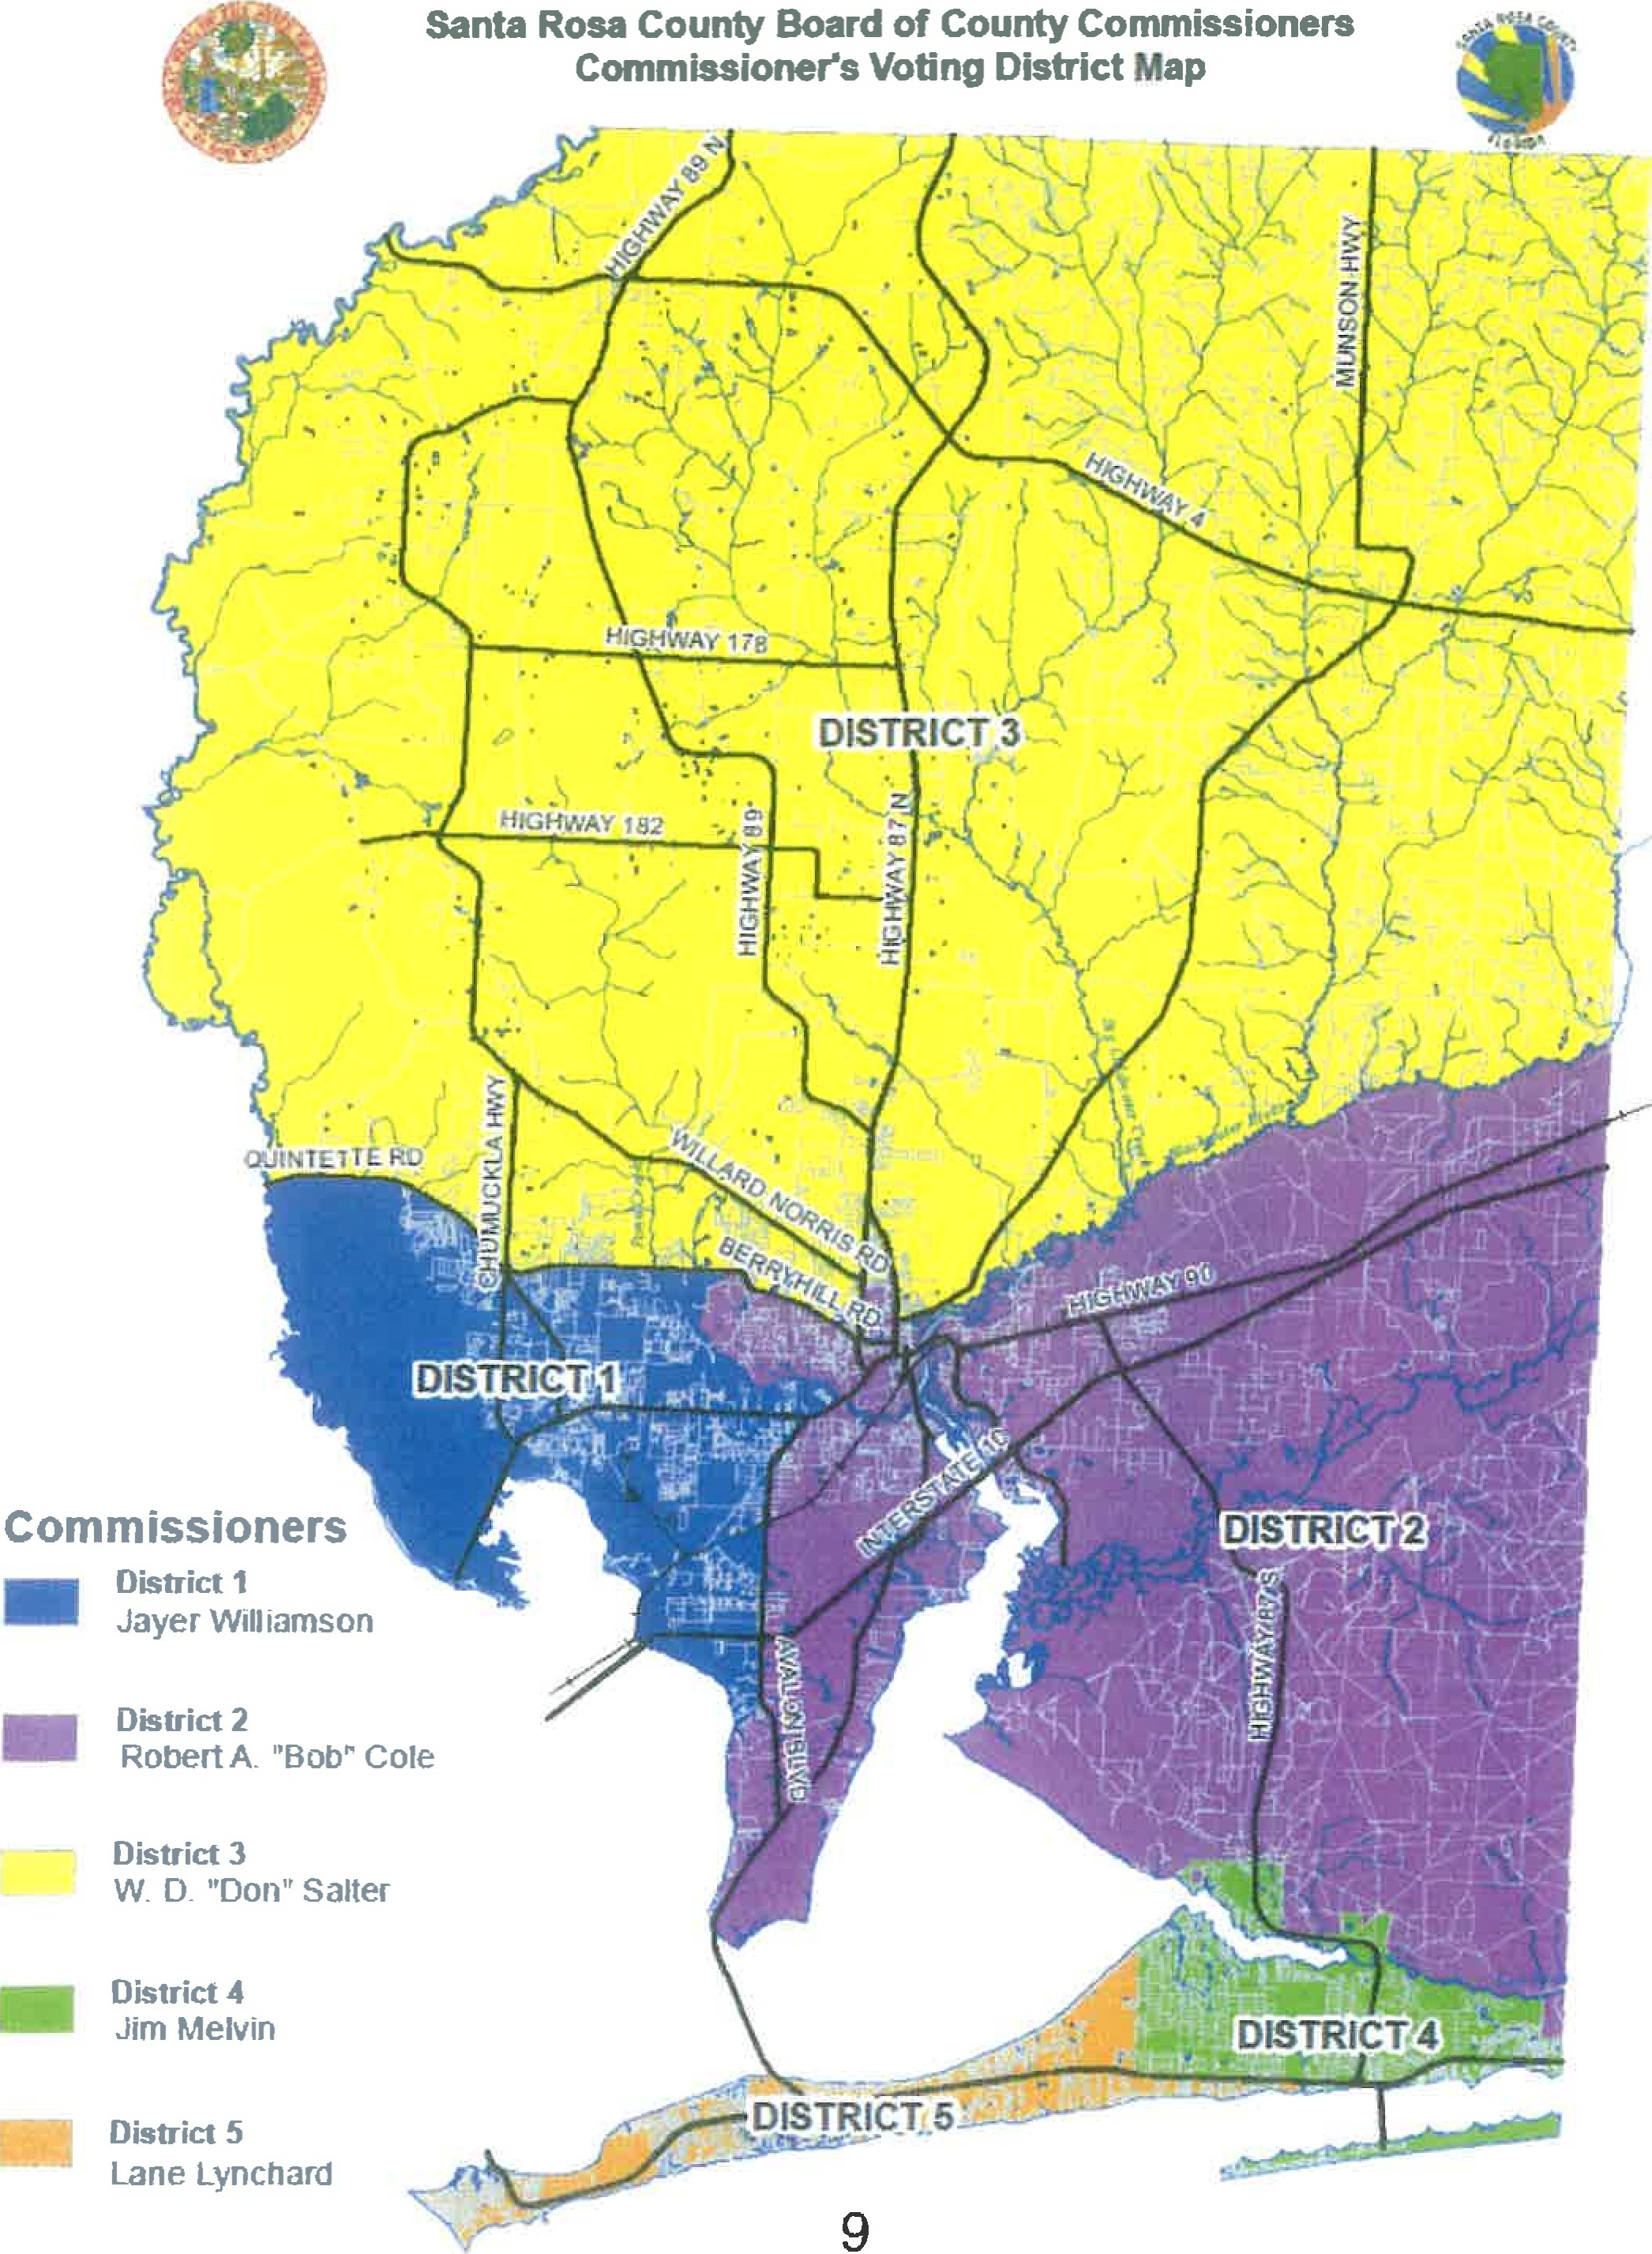
Santa Rosa County Board of County Commissioners Commissioners Voüng District Map

Santa Rosa County Government Suggested Activities
- Which county district do you live in? Who is your county commissioner?
- On the county commission web site click on the menu item labeled "Reports and Information." Then click on the most recent Annual Report
- On the page that shows the 26 offices under the supervision of the County Administrator locate parks, animal services, emergency services, and library services. Choose two of these and find them described in the rest of the report Tell what they do.
- Under County Statistics find out who has the largest budget? Why do you think that much money is needed.
- Where does the countys money come from? What does the budget department do? What does the property appraiser do? What does the tax collector do? Who collects money from court decisions and traffic tickets?
- Locate the fire stations near your school and near your home. Can you locate the fire hydrants near your home and school?
- Think of a particular concern that you have regarding a county service and write a letter to your county commissioner to ask about it
NIILTON CITY GOVERNMENT
Milton is the county seat of Santa Rosa County, Florida. Officially incorporated in 1844, Milton has a Council — City Manager form of government, established by Charter. With a population of almost 10,000 people (2012 census data), Milton is divided into four wards. The City Council consists of a total of eight (8) members, elected at large by all voters to represent the four wards.
Executive Branch: A mayor is elected for a term of four years by the citizens and is the official head of the city for all ceremonial purposes. S/he presides over city council meetings and has veto power over any ordinance approved by the council, but does not vote unless there is a tie. A City Manager is hired by the Council to oversee the daily delivery of public services and supervises all departnents of the city government, including appointing, disciplining, or removing all offcers and employees. The City Manager presents recommendations to the City Council on the requirements of municipal government and is responsible for submitting a budget to the City Council for amendment and approval. A City Clerk is also appointed by the Council.
Legislative Branch: The City Council is the legislative branch of government. Two council members from each of Milton's four (4) wards are elected at large by all voters, for a total of eight (8) city council members. The council legislates by adopting ordinances, regulations and resolutions, as well as exercising powers not conferred by the Charter on any other offce. The city council meets monthly in the council chambers at City Hall to discuss business and vote on proposals. Interested citizens may appear at the public meetings and speak in favor of or against proposals to be voted on.
Sunshine Law: All meetings of the City Council are subject to the "Sunshine Law," which states that when any of the council members meet to discuss business of the council, all members must be present and the meeting must be open to the public.
Departments of City Government: Several divisions of city government are represented by standing committees which meet regularly. These include:
- Finance
Administation
Growth, Development, and Annexation
- Public Works
Parks and RecreaGon
- Public Safety
Stormwater Management
- Firefighters
- Police
Human Resources
- Code Enforcement
Finances: The council adopts the budget for the city. Money for running the city government comes from several sources, including taxes (primarily ad valorem property taxes) licenses, fees, and state revenue sharing.

Sources: http://wwweci.milton.fl.us/; https: library.municode.com

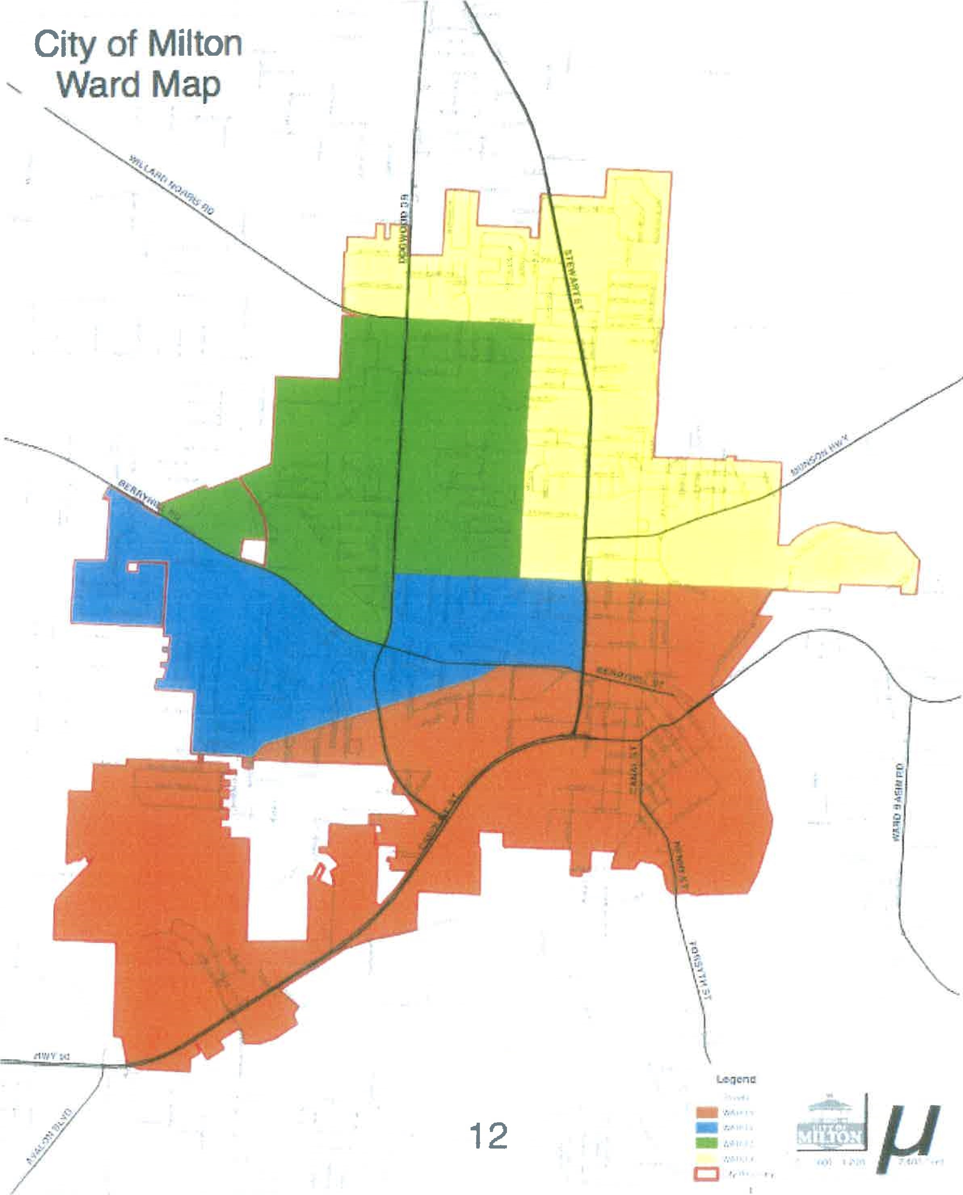
CITY OF MILTON SUGGESTED PROJECTS
Suggested Projects:
What is your City Council ward number? Who are the two representatives from your ward? 1. Go to the City of Milton website, http:/lwww„ci.milton.fl.us/_ , and find out when the next City Council meeting is. Attend the meeting, if possible. If not, read the minutes from the last recorded Council meeting.
- Is there an issue that one of your representatives expressed an opinion or position on?
- Do you understand his or her reasoning for that position?
- Explain his or her position.
- Do you agree or disagree? Why?
- Write a letter to your representative on this topic, or make an appointment to talk to your representative about this.
- Describe how the interaction with your representative worked out.
- Find the Charter for the City of Milton on the website https://www.municode.com/library/fl . List the six areas covered by the Charter. Under "Ordinances," find out who establishes the rules, regulations, and fees for the city parks.
- Look at the budget for this fiscal year and describe where the city's money comes from.
  - How is this money collected?
  - What does the city spend money on?
  - What happens if there is not enough money to cover the expense?
  - Who decides if taxes or fees need to be raised?
  - Who decides ifa service needs to be cut and by how much?
- Explain the "Sunshine LaW' as it applies to city government
- Collect information about a local topic that interests you, such as speed limits, speed bumps, garbage collection and disposal, recycling, stoplights, stop signs, summer recreation projects, leash laws, or noise ordinances.
  - Is this a city, county, or state area of control?
  - Find out which department oversees that area, how they make decisions, and where their money comes from.
  - Write a letter to the appropriate representative about your interest
  - Report on the response.
- During an election, research one or two candidates for one office.
  - Find out what qualifications the person has for the job.
  - Find out what the person's goals are, if elected.
  - Do you agree with those goals?
  - Are the goals something that a person in that job could actually accomplish?
  - Where would the money to accomplish those goals come from?
City of Gulf Breeze Local Government Page 1
Government:

Overview
The City of Gulf Breeze operates under a council-manager form of govemment, The mayor and council are responsible for making policy decisions for the community.
Appointed by the City Council, the City Manager (a paid position) is the chief executive officer for the City responsible for establishing organizational goals and providing overall adminisfration and direction to all City departnents.

City Manager
The City Manager's offce coordinates, implements, and evaluates all policies, procedures, and programs. The City Manager develops recommendations and provides information the City Council requires in order to establish policies and directives. In accordance with the City Charter, this office prepares reports, submits the Annual City Budget, monitors expenditures, and provides and/or coordinates support services and resources to the City Council. This office is also responsible for citizen relations and citizen communications.
Currently, there are 10 deparånents (refer to organimtional chart) within city govemment all of which report to the City Manager. The City Manager's staff consists of the two (2) City Clerks and Assistant City Manager.

City. Council and Mayor
The mayor and council are responsible for making policy decisions for the community. The council meets the third Monday of the month at 6:30pm. The agenda is posted on the web site on the Friday preceding the Monday meeting. City council minutes are posted on their web site. Special meetings can be called by the Mayor for special concerns of the community.

Mayor
The Mayor is an elected, nonpartisan position and serves for a two (2) year term. They serve in a volunteer capacity and receive an annual "salary" of $1.00. The mayor serves as chairperson for the City Council,

Council Members
The four council members are nonpartisan, elected at-large and serve four (4) year terms. They serve in a volunteer capacity receiving an annual "salary" of $1.00. Council seats are reelected in a staggered pattern whereby only two (2) council seats are replaced every two (2) years.
City of Gulf Breeze Local Government Page 2
Finance:
The budget document is the annual financial plan for City operations for the period covering one fiscal year. The City of Gulf Breeze's fiscal year begins on October 1 and ends on September 30. This plan describes the sources of revenues and how the funds will be spent during the year. The annual operating budget is the key document which describes the projects to be accomplished and the City's financial status each year.
Beginning mid-July, the City Manager presents the proposed budget to the City Council during a number of City Council workshops. The City Council meets to review and discuss the budget with the City Manager and each Departnent Director.
In accordance with the Truth In Millage Act, the City Council holds a public hearing on the Millage Rate and Proposed Budget prior to the adoption of a tentative millage and budget ordinance, generally by early September. By mid to late September, the City Council adopts by resoluüon of the final Millage Rate and Budget that serves as a financial planning and work plan for the next fiscal period.
The money for the running of the city govemment comes from several sources. A large source of income comes from propery taxes, also called Ad Valorem Taxes, other taxes and franchise fees and revenue from such departments such as water and sewer.

http://cityofgulfbreeze.us

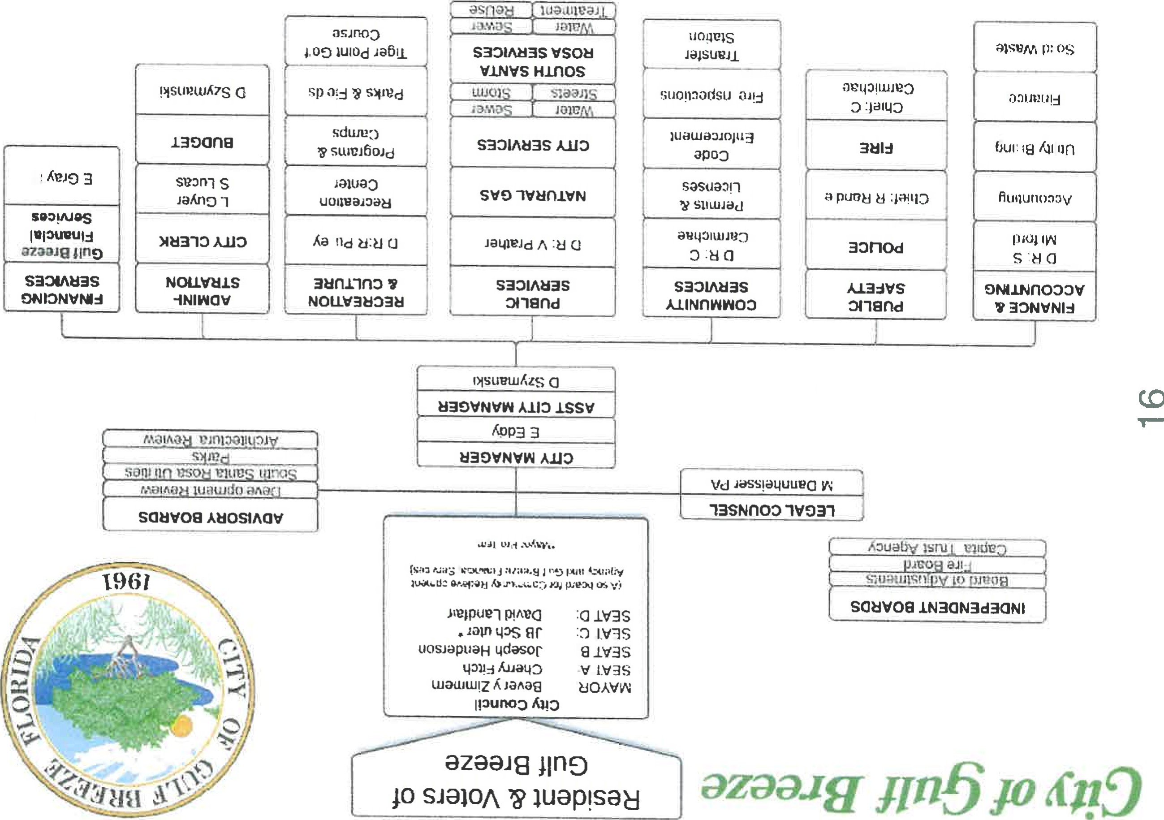

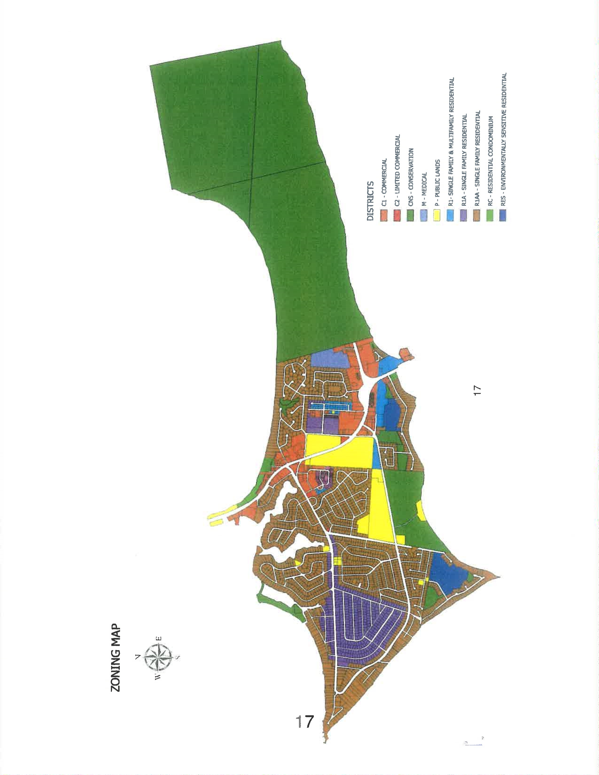

City of Gulf Breeze, Suggested Activities
- If you wanted to ride a motor scooter or go-cart what are the rules that you must follow in the City of Gulf Breeze? Using the web page (http://cityofgulfbreeze.us) determine where you can read the rules.
- What is the area code for Gulf Breeze, what number would you dial for an emergency, what number would you dial if you wanted to pay your utility bill? and what number would you call for a non-emergency request?
- Collect information about a local topic that interests you such s speed limits through the City of Gulf Breeze, or leash law and write a brief report.
- How often does the city council meet and how can you find out what is going to be discussed at the next meeting? Attend a city council meeting and up a short report using the published agenda.
5.. What are the sources of revenue/money that the city uses to operate its services?
6. The city of Gulf Breeze has a volunteer fire deparmlent. How old do you have to be to join this volunteer organization and do you get paid for your service?

Town of Jay Local Government Page 1
Jay is a small, rural town in the northern part of Santa Rosa County. It serves a population of approximately 650 people.
Jay has a Mayor-Council type of government. Being the executive authority, the Mayor and the council is devoted to the overall development of the small town.
Mayor: elected position: 4 year term
Council-members: 4 persons elected for a 4 year term
Both the Mayor and council members receive a monthly stipend for their service.
The town council meets at the Town Hall on the first and Third Monday at 6:00p.m. All meetings are open to the public. All the council work is done at the meeting and the agenda can be picked up at the Town Hall on meeting day. If an individual would like to be placed on the agenda, they can call city hall at (850) 675-4556 and they will be added to the agenda. Minutes are posted on their web site ) as soon as they are approved at the following meeting
The Town Hall serves as the main of hub for business, such as paying utility bills, obtaining permits etc. The progressive economic growth of Jay has its roots in a consistent businessfriendly policy followed by the Mayor-Council government over the years. Water and gas supply, sewer, comprehensive zonal planning, building approval, industrial park, and a host of other fast-spaced civic services have come as a big boost to the prosperity of residents and businesses in Jay.
Sheriff
Located in the rural community of Jay, District Five of the Santa Rosa County Sherif's Office encompasses more than 500 square miles and serves as the largest territory of all the districts. District Five works closely with the Alabama Sheriffs Office, the Escambia County Sheriffs Office in Florida, the Brewton and Flomaton Police and Fire Departments.
Personnel working at this office consist of: Lieutenant, Sergeant, Corporal, Deputy Sheriffs, and Administrative Clerk Il. 850.675.4335
Fire
Jay is serviced by the Santa Rosa County Volunteer Fire Department, Station 27.

19
Town of Jay Local Government Page 2
Financing/Budget
Monies to support town activities come from a variety of sources. Jay receives State funds from Sales and Fuel Tax, Local Option Gas Tax, and Mobile Home Tax. Other sources include Gas Royalties, Natural Gas Department, Water and Sewer, Ad Valorem Tax, Occupational
Licenses, Franchise Tax, Communication Services, sales of Cemetery Plots, Electrical Franchise Tax, rental from United Postal Service, and from county for Municipal Parks
Schools
Jay is in Santa Rosa County School District 2. Funding for the combined Jay elementary/middle school (grades K-6) and the combined middle /high school (grades 712) is received from the Santa Rosa County.
h.ttp://www.toyvnofjayfl.com
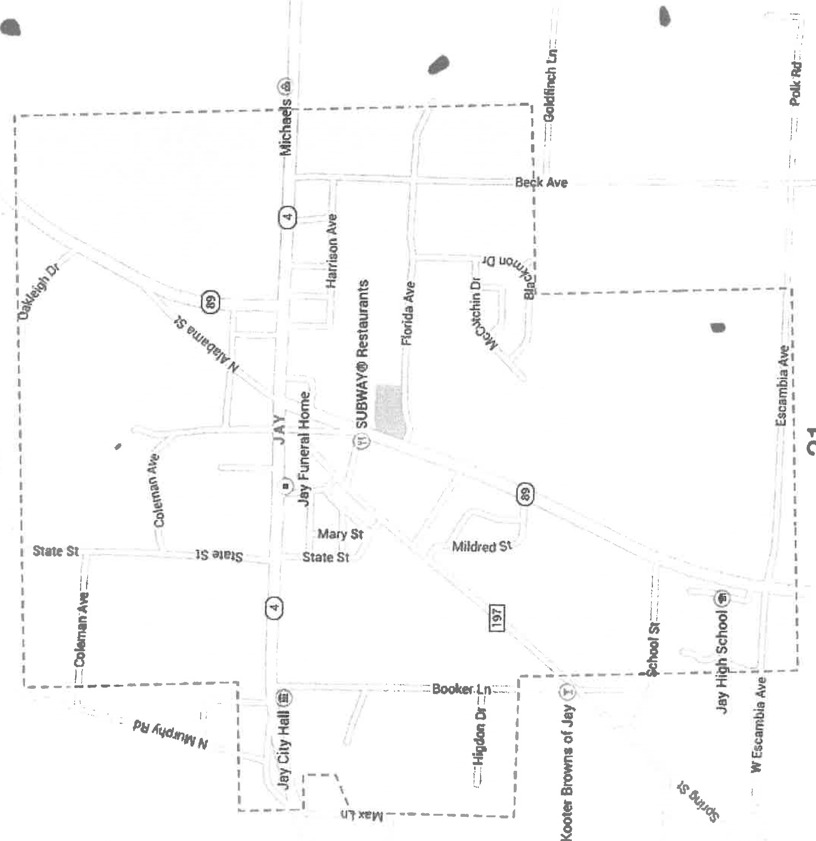
PE 1.10% wttw Scott
Town of Jay Suggested Projects
1 .Describe Jay's style of government?
- V^{s}hat are the term limits for the mayor and the town council members?
- Name 4 sources of revenue for Jay.
- When and where are Town Council Meetings held? How would you obtain a copy of the meeting agenda?
- miat is the central hub for government business for Jay residents?
6.How is fire protection provided for Jay residents?
7. Describe how law enforcement is provided for Jay residents and businesses?

Follow Your Florida Legislature
An important part of the business of the two bodies of the Florida Legislature is to create the laws needed for the safety and benefit of the people of the state. These laws are proposed as bills by the legislators, reviewed and revised in appropriate committees, and then voted on by the House of Representatives and the Senate separately. When approved by both, they are then sent to the governor for final review and, if approved, signature.
The citizens of the state can follow the proposed pieces of legislature, the bills, on the internet. If there is a particular subject that a citizen is interested in, the Senate and the House web sites provide search functions where the bills on that subject can be located and followed. In fact, if you have a particular interest in a bill or a group of bills, there is a place to enter your email address and flag those bills. Every time one of your bills moves, you will be notified by email.
A bill can be started in either the House or the Senate by a member or a group of members of that body. If you have requested to be notified, as a bill is proposed by either body, you will receive an email telling you its status. When it goes to a committee you will be notified. When it leaves that committee you will learn what the vote was from that committee. It may then go to another committee or to the main body for vote. You will be notified of all this as well.
If the bill starts and passes in the House, then it will go through the same process of committees and votes in the Senate. If it starts in the Senate, it goes through the same process of review, committees and vote before being sent to the House. Once it has passed both bodies it is sent to the Governor. As you search for a bill on a particular subject, you will usually find that similar bills are being considered in both houses at the same time. Theses are called companion bills. If a similar bill is fraveling through the process in both houses at once, the time it takes to reach the governor's desk, is considerably shortened. When it finally goes through both bodies and is signed by the governor, it becomes a law.
Legislature Suggested Activities:
- Go to the Senate's web site or the House of Representatives' web site and locate a bill or set of bills on a subject of interest to you, such as bicycle helmets, or invasive species.
- Find out the status of that bill. Flag that bill to be notified when it moves.
- Look up the committees it goes through. Why was that bill sent to those particular committees?
- Is that bill partisan? In other words is it of particular interest to a political party? In what way is it partisan, or not?
Resources:
wwwawfloridahouse.gQV

